Journey Line: Description

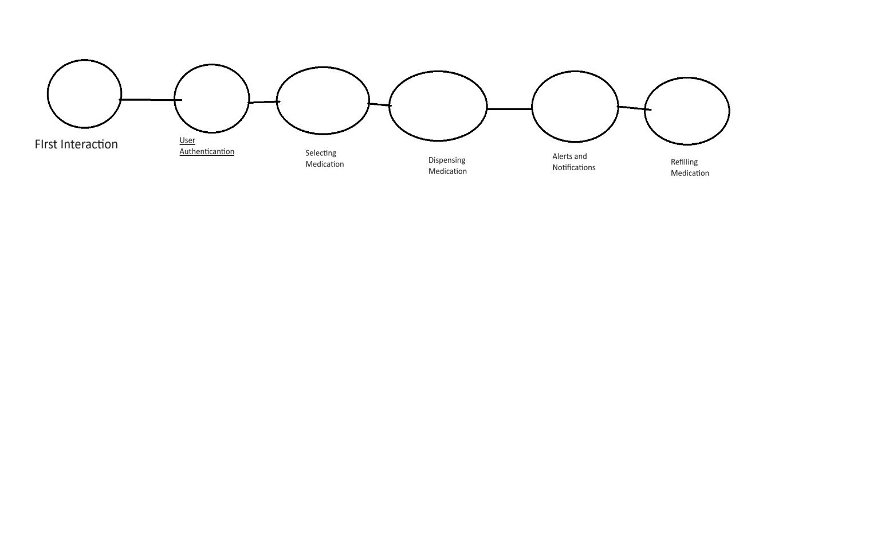

* The First node on the journey is the first interaction, is when the user turns on the drug dispenser which is a neutral step.
* This second node verifies the user’s identity to ensure safety and security which is a positive step
* The third node is when the user chooses medication, they need which provides a sense of control which is positive.
* The fourth node is when the machine dispenses medication which is a positive step.
* The fifth node is alerts and notifications, this step notifies the user of success in dispensing the medication and other information relevant to the transaction, which is positive.
* The sixth node is refilling which can be considered neutral because it depends on how often the user refills or their habits.